We’re all in this together. Just 6 feet apart. Together we can slow the spread of COVID-19. Don’t let the cold keep you from being active. If it’s cold outside, bundle up and go for a walk, run or bike ride. Add an extra layer of clothing to keep warm. Wear a sweatshirt, sweater or long-sleeved shirt under your coat. If you get too warm, take off a layer. www.cdph.ca.gov/COVID19 | 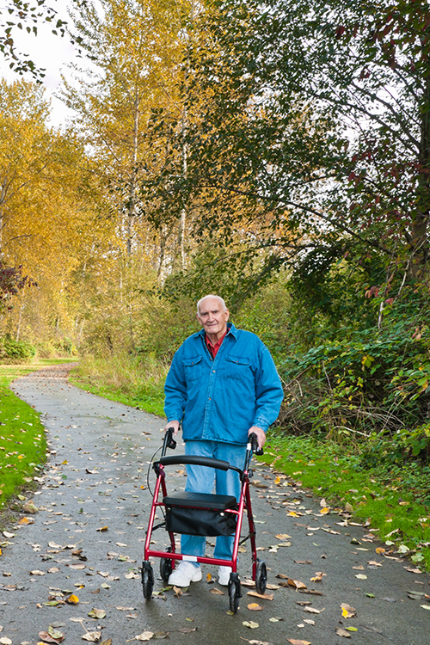
We’re all in this together. Just 6 feet apart. Together we can slow the spread of COVID-19. Get Moving. Physical activity strengthens your bones and muscles. Plus, it improves your mood and mental health. So, get moving! www.cdph.ca.gov/COVID19

We’re all in this together. Just 6 feet apart. Together we can slow the spread of COVID-19. Daylight savings began last month, which means another full hour of daylight! How will you spend that extra hour of sunshine? Try taking a walk or bike ride after dinner. www.cdph.ca.gov/COVID19

We’re all in this together. Just 6 feet apart. Together we can slow the spread of COVID-19. Spring into health by increasing your physical activity. Work in the garden, ride a bike, or take a walk. www.cdph.ca.gov/COVID19

We’re all in this together. Just 6 feet apart. Together we can slow the spread of COVID-19. Tai Chi can help reduce stress and build strength in your muscles and bones. Its slow, steady action can also help increase flexibility. www.cdph.ca.gov/COVID19
Make sure to eat healthy during our fight against COVID-19. Enjoy high protein snacks like nuts, cheeses, hard boiled eggs or hummus that can help us stay full longer and give us energy. Try a different snack each week. www.cdph.ca.gov/COVID19

Make sure to eat healthy during our fight against COVID-19. Make half your plate fruits and veggies for every meal. Try a new fruit or veggie each week to help keep your heart healthy! www.cdph.ca.gov/COVID19 | 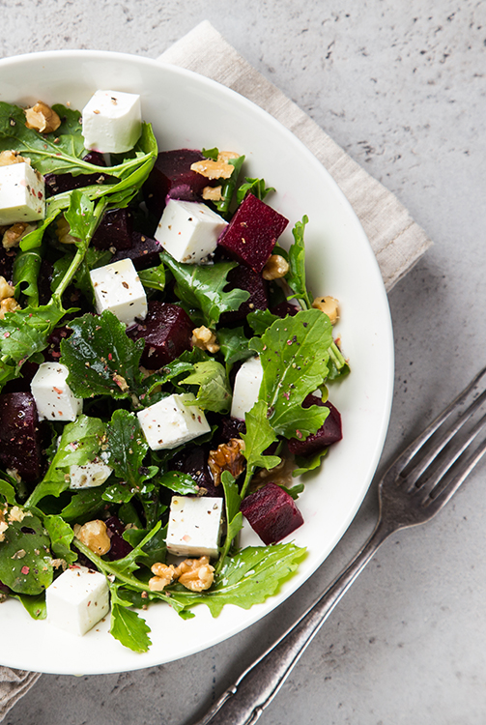
Make sure to eat healthy during our fight against COVID-19. Did you know that apples are one of the most popular fruits in the U.S.? They’re typically available year round. Apples are great as a snack or cut up in a salad. Choose a different type of apple each time you shop. www.cdph.ca.gov/COVID19 | 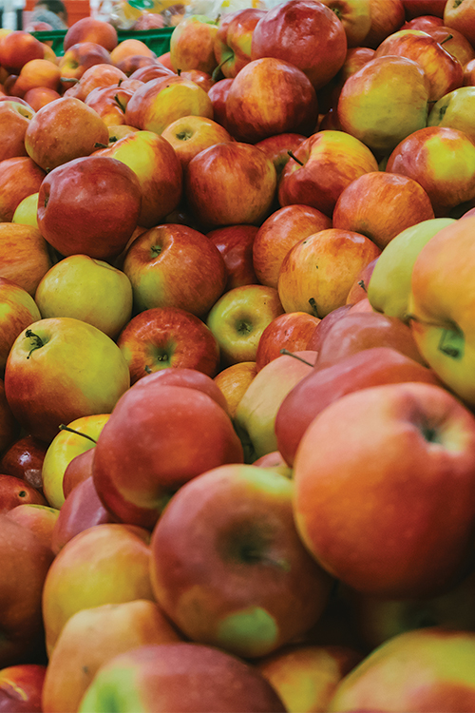
Make sure to eat healthy during our fight against COVID-19. Eating healthy doesn’t have to break the bank! Here are few ways you can shop smart and save money on fruits and vegetables. Try a new fruit or vegetable each time you shop.  - Try canned or frozen fruits and vegetables.  - Buy items in bulk when on sale.  www.cdph.ca.gov/COVID19 | 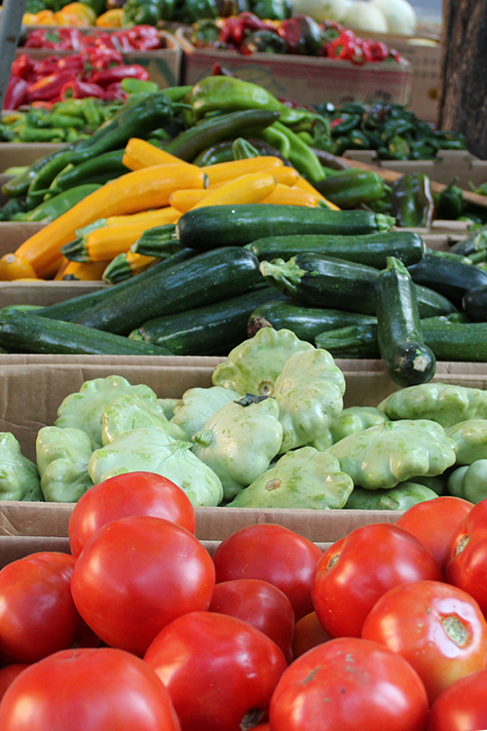
Make sure to eat healthy during our fight against COVID-19. Beans are an excellent source of plant protein. Dry beans are in season all year long and have a long shelf life. Beans can also be found canned or frozen. Buy a new variety each time you shop. www.cdph.ca.gov/COVID19 | 